# EX 1

1. package roshniS143;

import java.util.Scanner;

public class odddoreven

{

    public static void main(String[] args)

    {

Scanner scanner=new Scanner(System.in);

System.out.println("Enter a number");

int num=scanner.nextInt();

if(num%2==0)

{

     System.out.println(num +" is an even number");

}

     else

     {

         System.out.println(num +" is an odd number");

     }

}

}

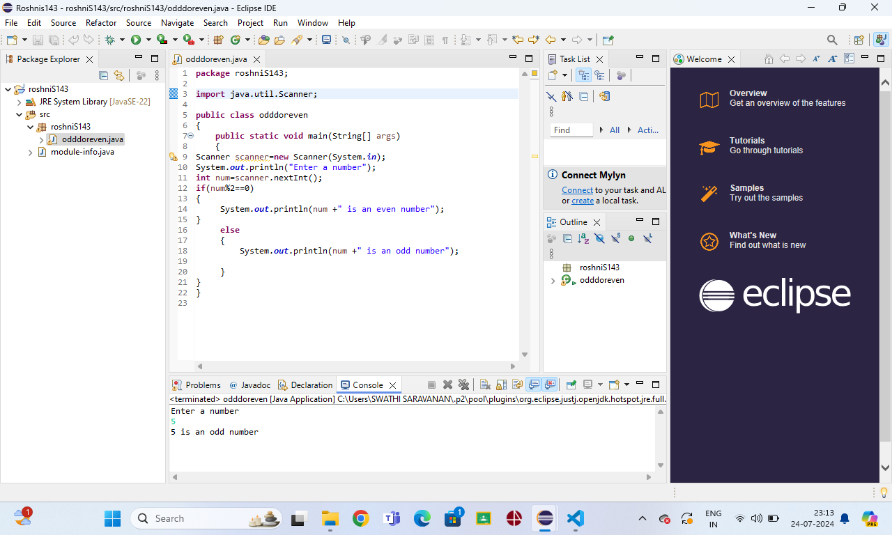

2. package roshniS143;

import java.util.Scanner;

public class posorneg {

    public static void main(String[] args)

        {

        Scanner scanner =new Scanner(System.in);

        System.out.println("enter a number");

        int n=scanner.nextInt();

        if(n>0)

        {

            System.out.println(n+" is a positive number");

        }

        else if (n<0)

        {

            System.out.println(n+" is a negative number");

        }

        else

            System.out.println("The number is zero");

    }

    }

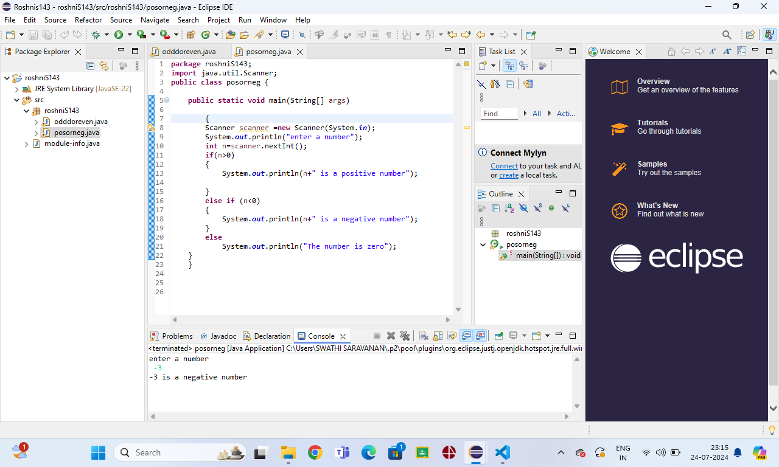

3. package roshniS143;

public class welc {

    public static void main(String[] args) {

    System.out.println("Hello everyone");

    }

}

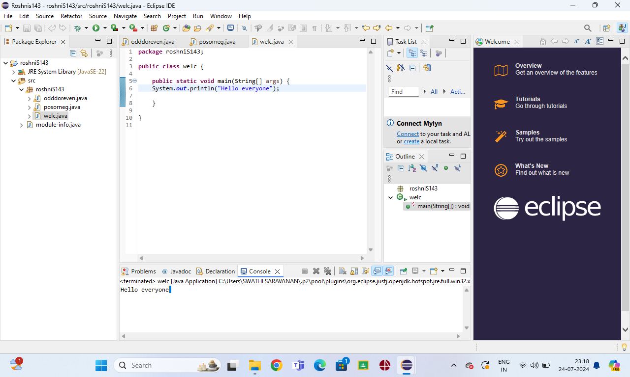

4. package roshniS143;

import java.util.Scanner;

public class leap {

    public static void main(String[] args)

    {

    Scanner scanner=new Scanner(System.in);

    System.out.println("enter a year");

    int year=scanner.nextInt();

    boolean isLeapYear=(year%4==0 && year%100 !=0)||(year%400==0);

    if (isLeapYear)

    {

        System.out.println(year + " is a leap year");

        }

        else

        {

            System.out.println(year + " is not a leap year");

}

    }

}

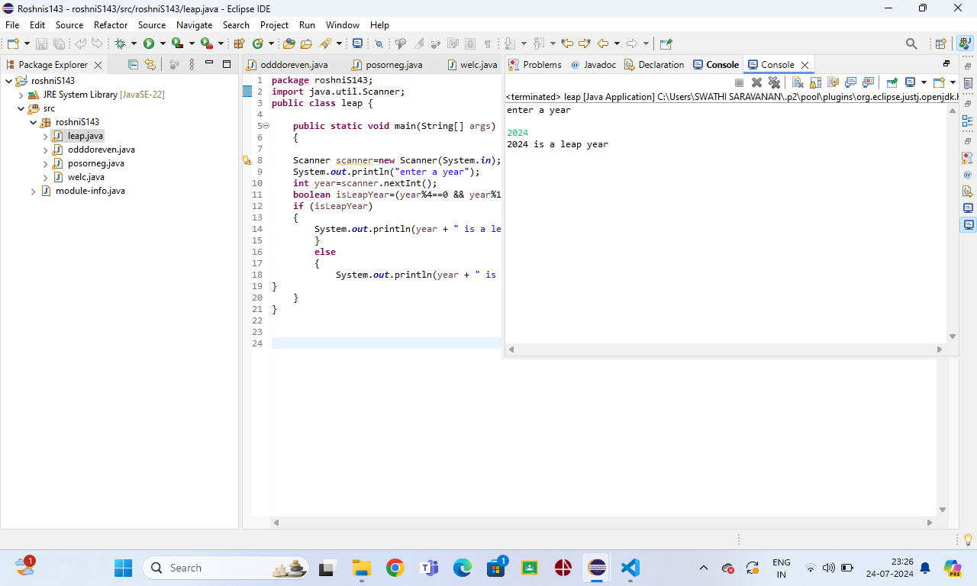

5. package roshniS143;

import java.util.Scanner;

public class calcu {

    public static void main(String[] args)

    {

        Scanner scanner = new Scanner(System.in);

        char continueChoice;

        do {

            System.out.println("Menu:");

            System.out.println("1. Add");

            System.out.println("2. Subtract");

            System.out.print("Choose an option: ");

            int choice = scanner.nextInt();

            System.out.print("Enter the first number: ");

            int num1 = scanner.nextInt();

            System.out.print("Enter the second number: ");

            int num2 = scanner.nextInt();

            switch (choice) {

                case 1:

                    System.out.println("Result: " + (num1 + num2));

                    break;

                case 2:

                    System.out.println("Result: " + (num1 - num2));

                    break;

                default:

                    System.out.println("Invalid choice! Please select 1 or 2.");

                    break;

            }

            System.out.print("Do you want to continue? (y/n): ");

            continueChoice = scanner.next().charAt(0);

        } while (continueChoice == 'y' || continueChoice == 'Y');

        System.out.println("Program terminated.");

        scanner.close();

    }

}

